1
Top margin 63.5 mm

Title of the Paper (12 pt. Arial, Bold, Centered, Word Case)
Single spacing, two lines

Name of the author1¹, author2², and author3³ (10 pt. Arial, Bold Centered)
1.5 spacing, single line

¹Affiliation of author 1 (10 pt., Arial, Italic and centered)
²Affiliation of author 2 and
³Affiliation of author 3
e-mail ID of the corresponding author (9 pt.Arial,Italic)
Single spacing, two lines

A concise abstract, containing only the results and discussion, of not more than 150 words is required. Do not write introduction in abstract. Leave two lines of space after the author’s affiliation (address). Give the e-mail ID of the corresponding author below the authors’ affiliation. The typing area for the abstract should be with in 133.35 mm width. Please type the text of abstract in Arial Italic font, size 10 pt. with right and left justification. Leave two lines of space below the abstract before beginning the text. (10 pt. Arial, Italic, Justified). The remaining part of the abstract has no meaning. It is only an example to show how a manuscript has to be prepared for NSC proceedings and subsequently to be published in the Indian Journal of Cryogenics. Three pre-series Test cells of the LHC cryogenic Distribution line (QRL), manufactured by three European industrial companies, will be tested in the year 2000 to verify the thermal and mechanical performances. The test cell comprises a LHC standard cell needed for test purposes.
140 mm

Key words: NSC22, Manuscript preparation, Maximum five key words (10 pt. Arial, Bold)
Single spacing, two lines

Introduction

Authors are required to prepare the manuscripts exactly according to the following instructions and as per this format. This will ensure that papers received for publication from different authors are consistent in style, format and quality. Authors are urged to write concisely. Manuscripts not conforming to the following instructions will be rejected. The manuscripts submitted on-line will be made available in the form of CD during the symposium as proceedings of the NSC. Hence, the submitting authors are requested to ensure that they are free from errors and conform to the guidelines. Selected papers after peer review will be published in the relevant volume of the Indian Journal of Cryogenics. The template you are reading now is as per the manuscript submission format of Indian Journal of Cryogenics and Superconductivity and hence it should be strictly adhered to while preparing the manuscript. The paper uploaded in the webpage will be used for the printing of the journal. Thus the final paper submitted should be as neat as possible. However, after peer review, there could be need for you to edit and resubmit the manuscript as per the instructions of the reviewer. In the following part of the text, the detailed instruction for the preparation of the manuscript is outlined. Important points are shown in red colour.
80 mm80mm

25 mm

25mm

25 mm
Maximum length allowed is 6 (six) pages for contributed oral and poster papers (including figures and references) and 15 (fifteen) pages for invited review papers (including figures and references).
Do not insert any page number while typing the manuscript. Actual page numbers will be inserted by the publisher in the text. Paper reference number which will be available later at symposium web site should be used as the file name while uploading the manuscript in the web site.

Title of the paper

Title of the paper has to be typed in upper and lower case with 12 pt. Arial, Bold, Centered and 63 mm below the top. Leave two single line spaces below the title and type the names of the authors in upper and lower cases with 10 pt. Arial, Bold and centered. Leave one line of 1.5 space and type the affiliation (address) of the authors in upper and lower case with 10 pt. italic, centered. If the addresses of the authors are more than one, type them one below the other using asterisk or any other symbol as shown in this template. Leave one line and type e-mail ID of the corresponding author in 9 pt. Arial italic.

Abstract
Abstract will follow the authors’ affiliation. A concise abstract not more than 150 words has to be typed leaving two lines of single space below the affiliation. It should be with 10 pt. Arial, Italic, and centered. The width of the abstract should be 140 mm. Leave two single line spaces below the abstract and type the key words with no indent, Bold and 10 pt fonts. Maximum five key words are allowed. After the key words, leave two single line spaces and start the text in two columns.
Manuscripts should be prepared for letter size paper (215.9 mm x 279.4 mm), in English, with single line spacing. The typing area is 170 mm wide by 229 mm height. (top, bottom and left margins should be 25.4 mm each except for the first page for which the top margin will be 63 mm). Type the text in two columns of 80 mm with a gap of 5 mm. Do not type outside this area and do not leave extra margins within them. The text should be typed in 11 point Arial font. There may by reduction of the overall size of the page for printing in the journal. Example of the first level heading is shown next.

Text format

Headings are not numbered. Type first-level headings all in capital letters, not indented. Leave two blank lines above each heading, and one blank line below. Start the text after each heading without an indent. Second level headings are typed in upper and lower case letters, not indented. Leave one blank line above but no blank line below. Text begins with an indent.
Indent (8.5 mm) the text at the beginning of each new paragraph but not after a first level heading. Do not leave a blank line between paragraphs. The text should be right and left justified. You can use either equation editor or any other suitable software for typing the mathematical equations. For mathematical equations, leave one blank line above and below each equation or set of equations as shown below.

$\frac{d}{\text{dx}}\left[k\left(T\right)A\frac{\text{dT}}{\text{dx}}+\frac{p\left(T\right)I^{2}}{A}\right]=αu(T−T_{g})$ (1)

The displayed equations should be aligned to the left hand margin. If the equations are numbered, set the equation number within parentheses aligned to the right hand margin.

Illustrations (Photographs and figures)
Colour printing is not possible for the journal except the invited review paper. However, it is possible to depict the colour figures and photographs in the CD brought for submission at the venue of the NSC. For printing in the journal, the colour photographs and figures will be converted to black and white and hence different colours will be converted as in corresponding gray tones. It can not therefore be assured that the details of the colour photographs and figures could be reproduced in the journal. All illustrations should be placed in the body of the text immediately after the citation. They should be clear and suitable for any size reduction if needed. Figures can be drawn separately and with the help of cut and paste option, inserted in the text at appropriate places. The ideal height of the letter in the figure should be between 1.5 mm and 2 mm. Very fine details or close contrasts of tone may not be reproduced well when printed. Place the figure caption centered below the figures. Type Figure 1, etc., leave two letter space and then type the figure caption. Leave one blank line space below the figure caption before starting the text.

Tables
Place caption centered above the table. Type Table number, leave two letter space and then type the caption of the table.

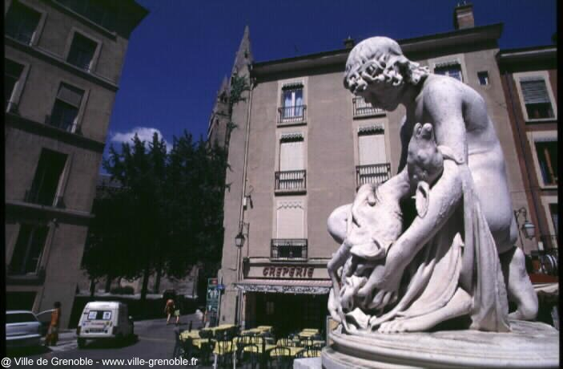

Figure 1. Sample photograph

The size of the text should not be less than 10 pt. If necessary, tables can be typed separately and using the cut and paste option, inserted into the text like pictures. While doing so, be careful about the text size when the size of the table is reduced.

Table 1 CFU Heat Loads pt.

Temperature level (K) | Heat load at I = 0A | Heat load at I = 13 kA
1.9 | 9.1 | ≅ 10
4.3 | 27 | ≅ 45
X | Y | Z
Xx | Yy | Zz
xxx | Yyy | Zzz
50 | 48 | 48
After the table, leave one blank line space below before starting the text. If tables could not be typed conveniently within the width of the column, there are two possibilities. (i) Type the table sideways on the page (‘landscape’). It will occupy the whole page in this case. (ii) type the table on a separate sheet, reduce it like any picture and place it at appropriate location taking care that it is in readable font size.
Three horizontal lines should be drawn for the preparation of table one at the top, one at the bottom and one after the column headings. Do not add vertical lines to the tables unless essential. After caption, leave one blank line space and place the table
0
20
40
60
80
100
10
12
14
16
18
20
Turbine discharge temperature (K)
Mass flow rates (g/s)
Cycle
Turbine
JT
Figure 2. Optimum of cycle mass flow rate
References (In the text and the list)
In the text, references should be indicated using Arabic numbers, in sequence, placed within square brackets viz. Smith [1] and Brown [2,3]. In the list, references are listed at the end of the manuscript in numerical order with 10 pt. font. Use the automatic number setting with left justification (as shown at the end of the template). The guidelines for preparation of the reference list are as follows:

- Authors’ initials should be typed first and followed by their surnames.
- Journal titles should be abbreviated according to Chemical Abstracts or Physical Abstracts style.
- Do not underline journal titles and book titles but type them in Italics.
- For references give authors name followed by the title of the article the volume number (in bold), page numbers (xxx - xxx) and the year of publication within parentheses.
- Do not use square or round brackets for the numbering in the list.

Acknowledgement

Acknowledgment may come at the end of the manuscript just before typing the reference list. This work was carried out under Department of Aaaaa & Bbbbby programme and active support of Xxxx Yyyyy and Zzzzz.

References

- Smith, A. and Brown, A. J., “Paper Title”, Cryogenics Vol. 103, pp 275-284. (1984)
- Kays, W.M. and London A.L. “Compact heat exchangers” 3rd ed. McGraw-Hill, New York, 1984.
- Alexeev, A., Ch. Haberstroh and Quack, H. “Low cost mixture Joule Thomson refrigerator”, Proceedings of 16th International Cryogenic Engineering conference, pp395-398, 1996.

Points to be noted:

1. Do not write introduction in the abstract of your manuscript. It should state concisely
the new findings/new interpretation/innovation of the studies reported in the MS. Abstract
given for the abstract book of the symposium need not be reproduced here.

2. Do not report data of your studies like in a thesis. Do not reproduce the page from the
computer screen either. Give the results of your studies and discuss them in appropriate
headings of “RESULTS” and “DISCUSSIONS”.

3. Do not give too many figures. Only representative figures should be given relevant to your
results. For example a particular parameter of several samples can be plotted in a single
curve rather than giving separate curve for each sample. This way comparison between the
parameters of different samples becomes easy.

4. Give prominence to the discussion part which should bring out your contribution to the field of
research such as new findings, anomalous results but well explained by the existing theories
or a new interpretation offered.

5. Manuscript prepared by a young researcher should invariably be checked by the guide for
proper presentation and the language. Our reviewers have often pointed out poor language
used in such MS. This complicates the situation as the MS is sent back, sometimes more
than once, for revision. This delays the whole process of publication.

